Framework Assignment

1. What are the advantages of Bootstrap?

Ans. Bootstrap is a popular front-end framework used for building responsive and mobile-first websites.

1.Responsive Design: Bootstrap's grid system allows developers to create websites that work well on all devices.

2.Pre-built Components :It comes with a rich collection of pre-designed HTML, CSS, and JavaScript components like navigation bars, buttons, modals, forms, carousels, and more.

3.Cross-browser Compatibility:Bootstrap ensures that the design works consistently across major browsers, including Chrome, Firefox, Safari, and Internet Explorer.

4.Mobile-first Approach:Bootstrap is designed with a mobile-first philosophy, meaning websites built with it automatically scale to fit mobile devices.

5.Customization and Flexibility:Although Bootstrap comes with predefined styles, it is easy to customize. Developers can override default styles by modifying CSS or using pre-built themes.

6.Consistent Design:Bootstrap ensures consistency across different pages of a website or even across multiple projects.

7.Wide Community and Documentation: Bootstrap has a large community, which means there are many resources, tutorials, and templates available online.

8.Time-saving: Because of its pre-built components, responsive features, and built-in JavaScript functionality, Bootstrap speeds up the development process significantly.

9.Open-source and Free: Bootstrap is an open-source framework, which means it is free to use for any type of project, from personal blogs to commercial websites.

2.What is a Bootstrap Container, and how does it work?

Ans:-

1. Fixed-width container:

As the screen size changes, the container adjusts its width to fit the screen size without exceeding Bootstrap's predefined maximum widths.

- Example:

html

<div class="container">

</div>

2.Fluid container:This container spans the entire width of the viewport, and it stays full-width regardless of the screen size.

- Example:

html

<div class="container-fluid">

</div>

How it works:

The grid system divides the layout into 12 columns, allowing you to align elements and create responsive layouts.

Breakpoints: Containers work in conjunction with breakpoints to make the layout responsive. For fixed-width containers the width adjusts according to the device's screen size at each breakpoint.

Example:

html

<div class="container">

<div class="row">

<div class="col-md-6">

Left column

</div>

<div class="col-md-6">

Right column

</div>

</div>

</div>

3.Make a card using Tailwind css

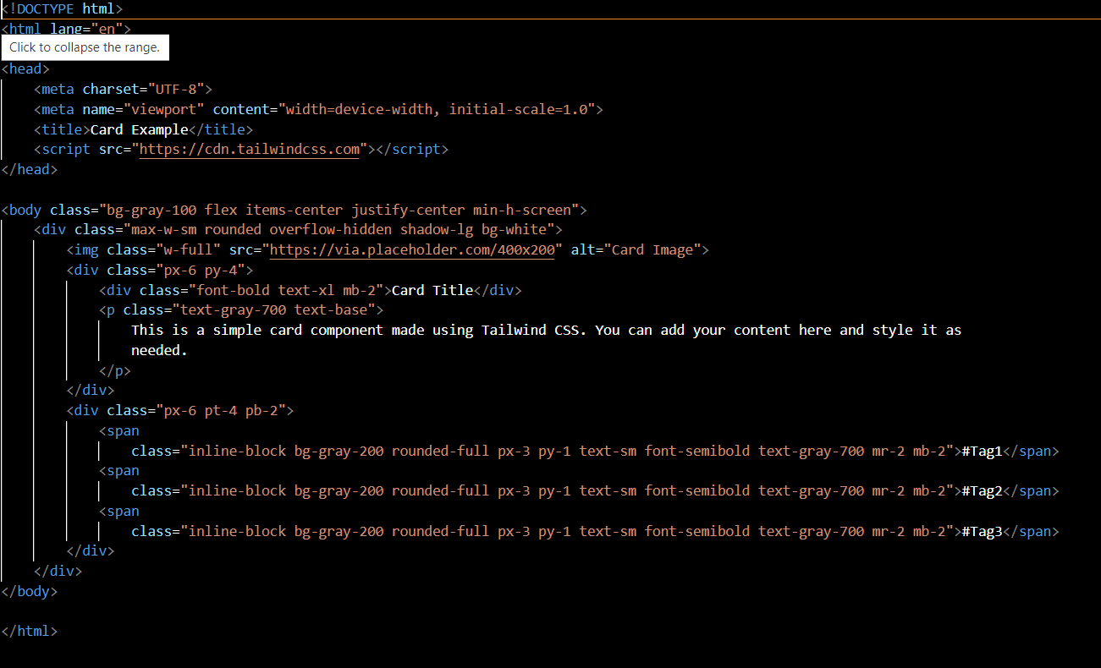

4. Create Slider

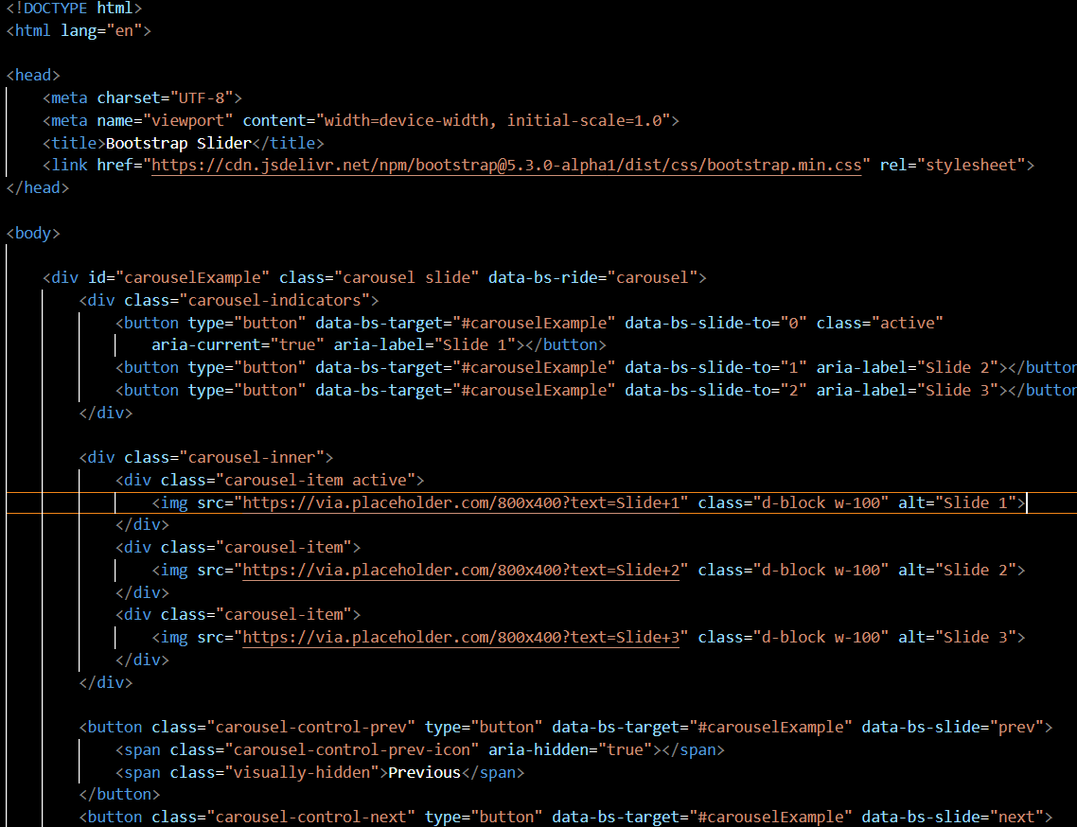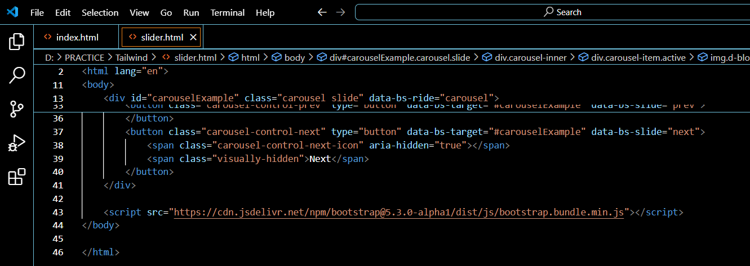

5. Create table using Tailwind also apply effective color